2026 NFL Playoff Madness

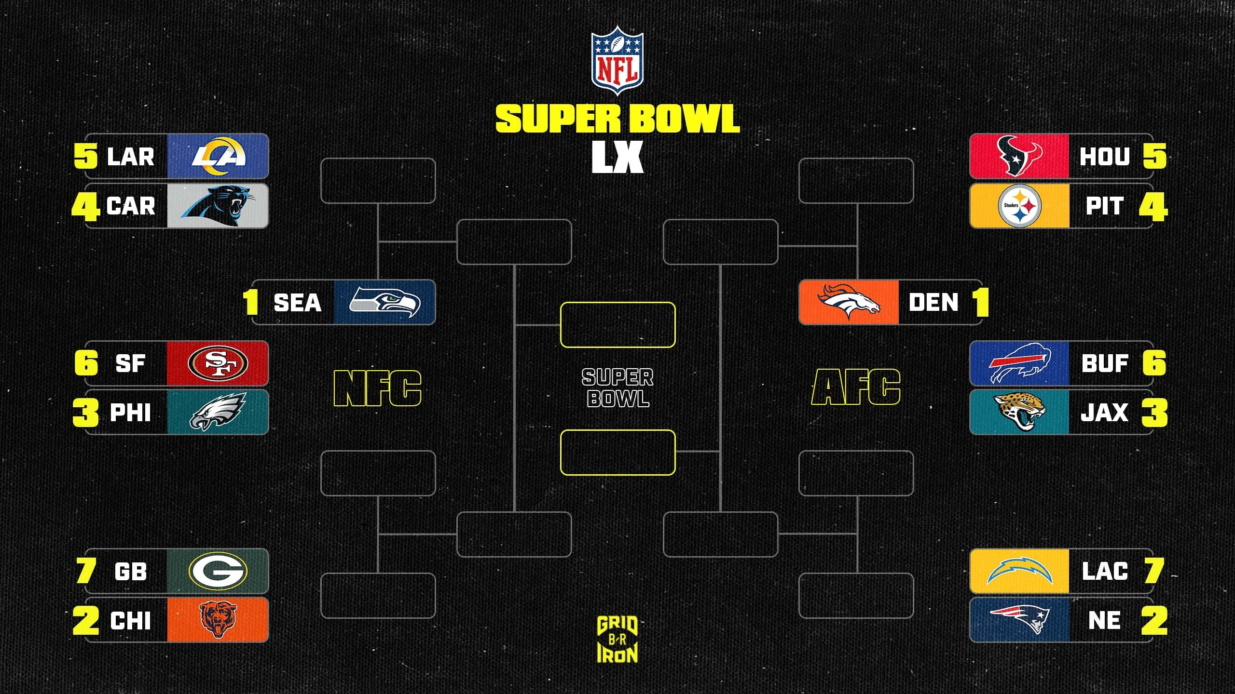

Entry fee: $20

Points will be awarded for each correct pick based on round.
Wild Card: 1 point
Divisional: 2 points
Championship: 3 points
Super Bowl: 4 points
Tie breaker: Total points scored in Super Bowl

Payouts will be determined later based on how many people we have play.

Pay special attention to the seeds of the teams that you pick to advance. In the divisional round of the playoffs the highest remaining seed will play the #1 seed. The matchups depend on the outcome of all of the games. I’ll double check the entries to make sure everyone has picked correctly.

If you are interested fill out the bracket and send me your picks if you want to enter. I found it easiest to fill the actual bracket out or create one on paper. Feel free to just send me a picture of it or whatever is easiest. You'll need to pay attention to the seeds that you pick to advance as that determines who plays who.

Send $20 and your list of picks in any format to James before he first wild card game starts on Saturday 1/10 at 1:30 PST.

AFC Wild Card Round:
#7 Los Angeles Chargers @ #2 New England Patriots: _____________________
#6 Buffalo Bills @ #3 Jacksonville Jaguars: _____________________
#5 Houston Texans @ #4 Pittsburgh Steelers: _____________________

AFC Divisional Round:
#? Lowest WC Seed Winner @ #1 Denver Broncos: ____________________
#? Middle WC Seed Winner @ #? Highest WC Seed Winner: ____________________

AFC Championship Round:
#? Lowest Divisional Seed Winner @ #? Highest Divisional Seed Winner: _____________________

NFC Wild Card Round:
#7 Green Bay Packers @ #2 Chicago Bears: ________________________
#6 San Francisco 49ers @ #3 Philadelphia Eagles: ________________________
#5 Los Angeles Rams @ #4 Carolina Panthers: ________________________

NFC Divisional Round:
#? Lowest WC Seed Winner @ #1 Seattle Seahawks: ____________________
#? Middle WC Seed Winner @ #? Highest WC Seed Winner: ____________________

NFC Championship Round:
#? Lowest Divisional Seed Winner @ #? Highest Divisional Seed Winner: _____________________

Super Bowl:
#? AFC Championship Winner @ #? NFC Championship Winner: _____________________

Super Bowl Total Points Scored: _________________

